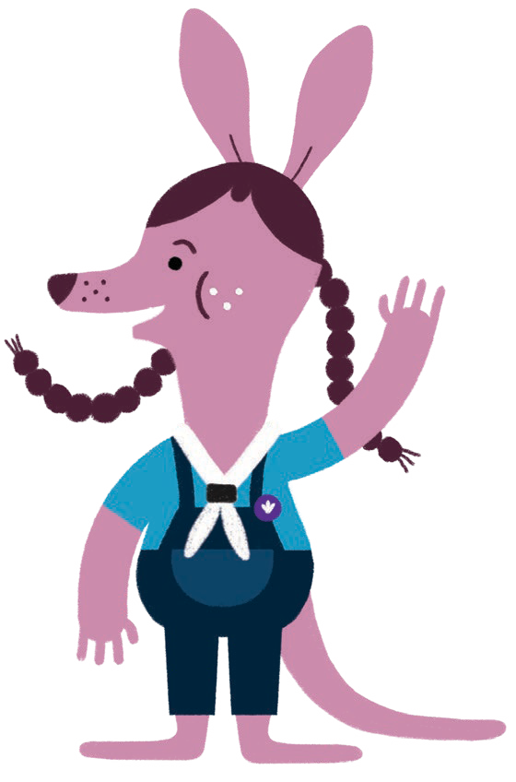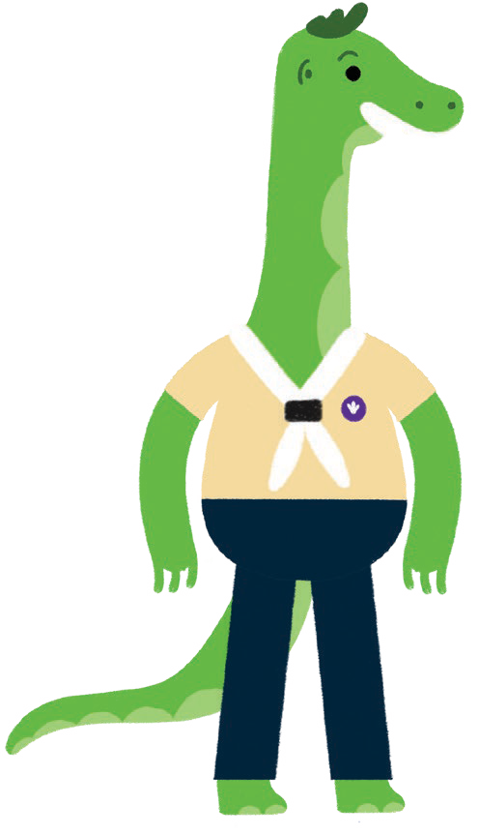OUR CODE

OF BEHAVIOUR

1. **We listen to each other**
2. **We let other people finish what they are saying without interrupting**
3. **We are kind to each other, with kind hands, kind voices and sharing**
4. **We help each other**
5. **We accept we are all different**
6. **We include everyone in our games**
7. **We always try our best**
8. **We look after our meeting place**
9. **We try to join in and have fun**